Chatbots on Sales
1.In sales schema, we have created the view: - sales dashboard.
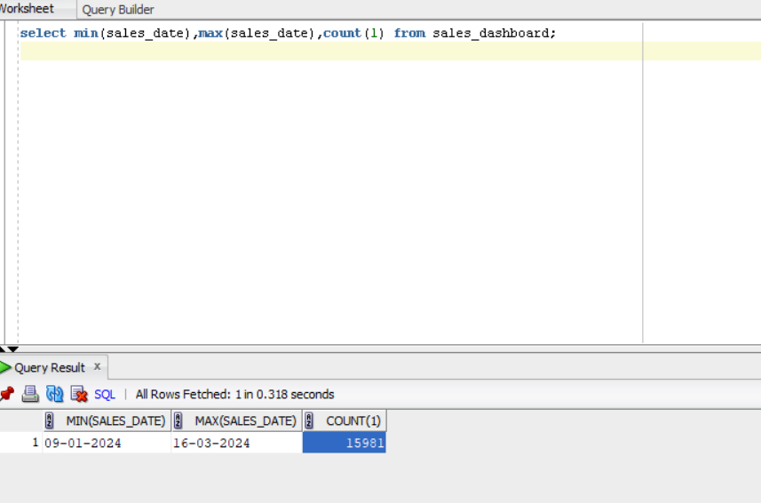
2.Now we will connect to python and store these data into Data Frame.
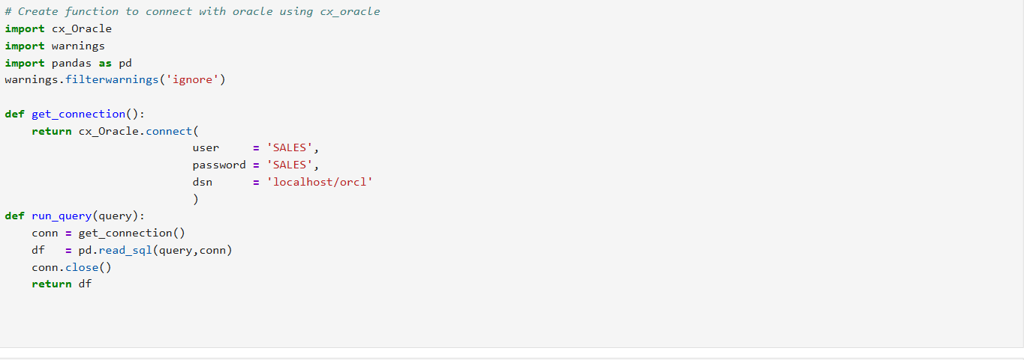

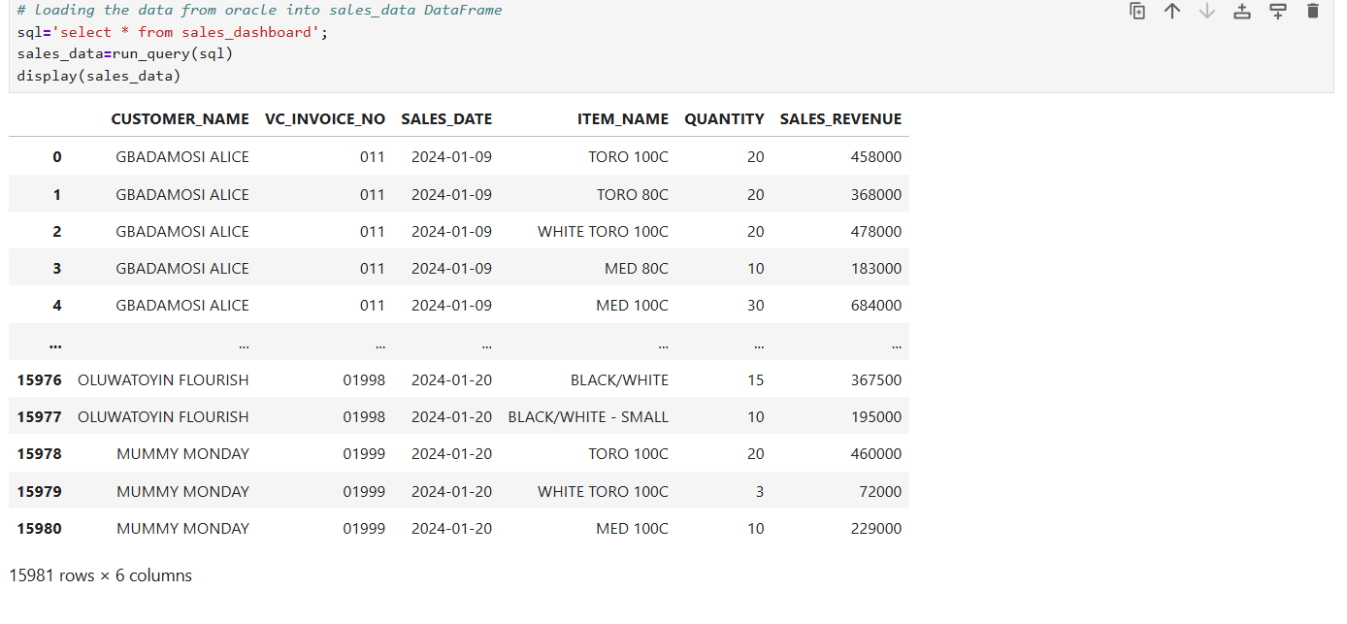
3.Now Data is loaded in sales_data and now we will convert these data into text format so that it will easy for embedding because embedding work for text data.
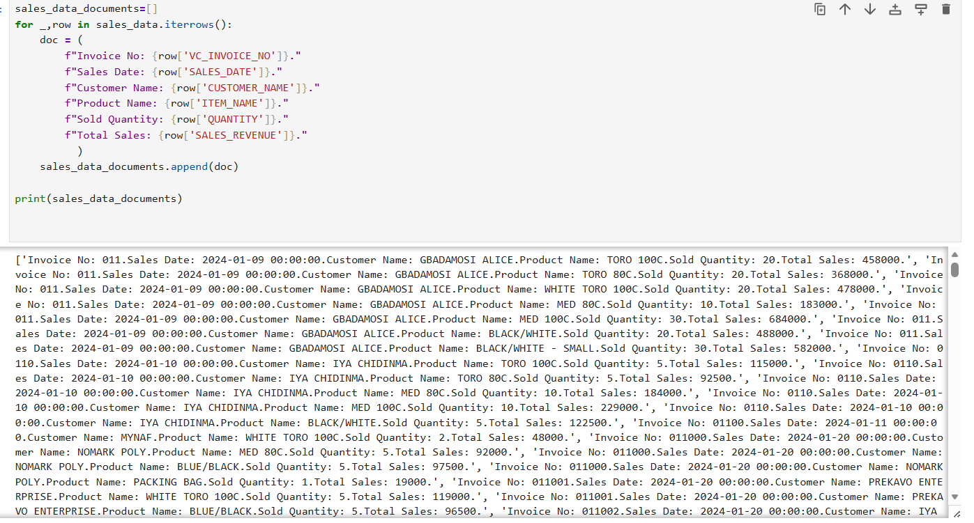
4.We will create an embedding so that we will convert text into numerical format.
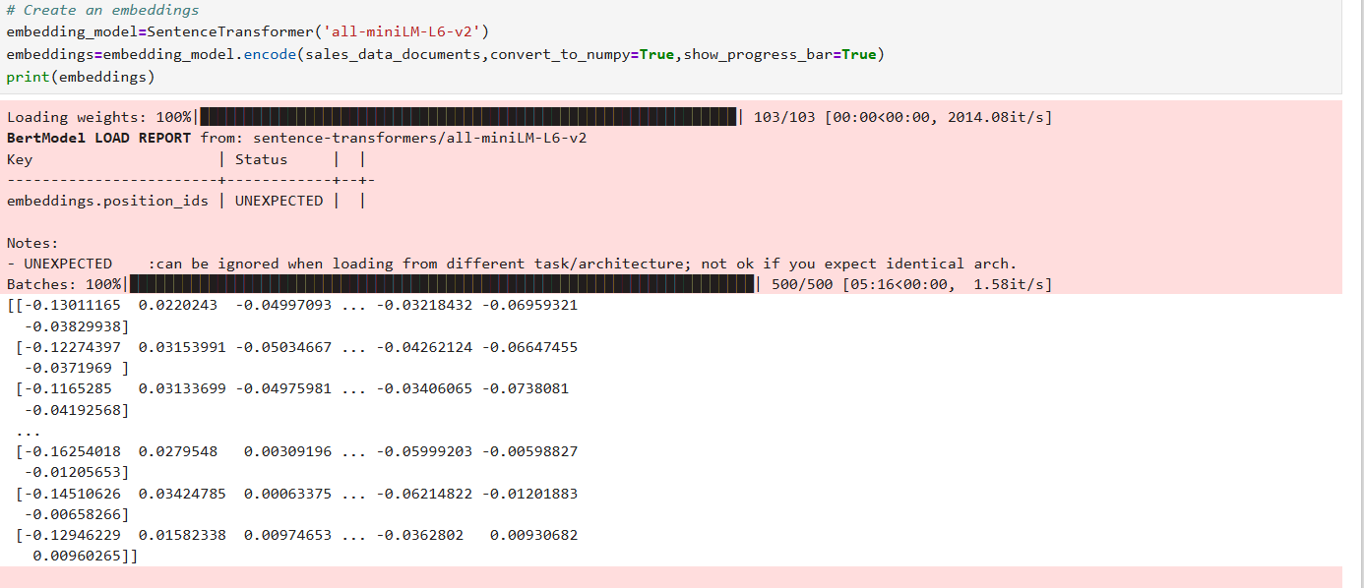
Shape of embeddings: -
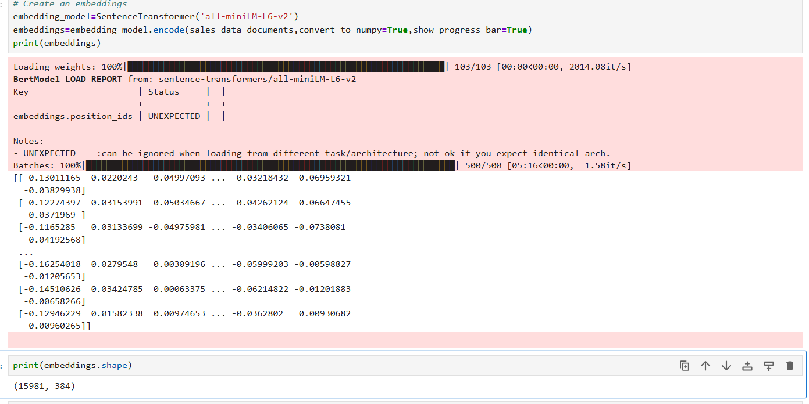

5. To store the embeddings into faiss vector database and index file created: -
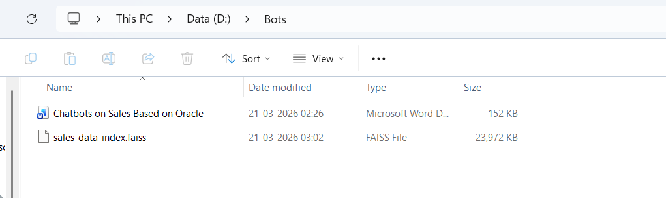
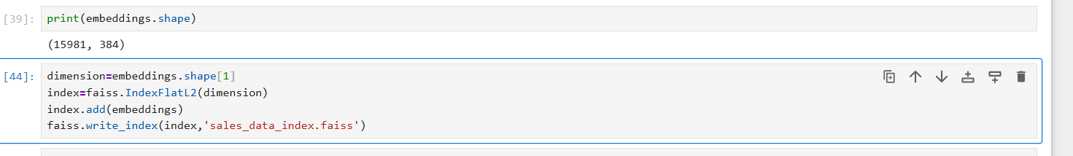
6.RAG Introduced here, will write the retrieval functions to fetch information:
User query will be encode first then index.search method use to find the distances for closest similarity (cosine).
7. Gemini model configuration :
max_output_tokens ,temperature(temp) helps the model to create response either creative or deterministic (0,1)
Higher the temp - Higher the creativity , lower the temp- the more deterministic response.
Then we will call the Gemini model ‘ models/gemini-2.5-flash‘
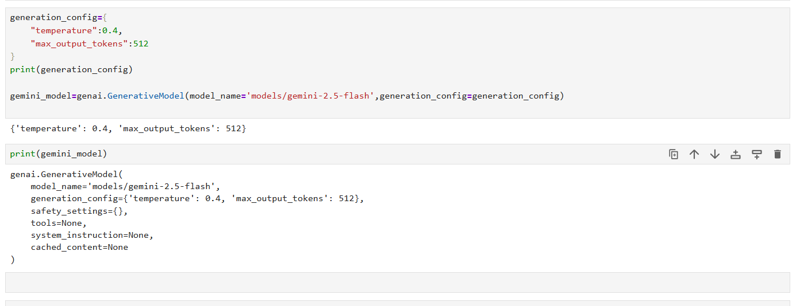
8.Now will create conversional bots using prompt engineering:
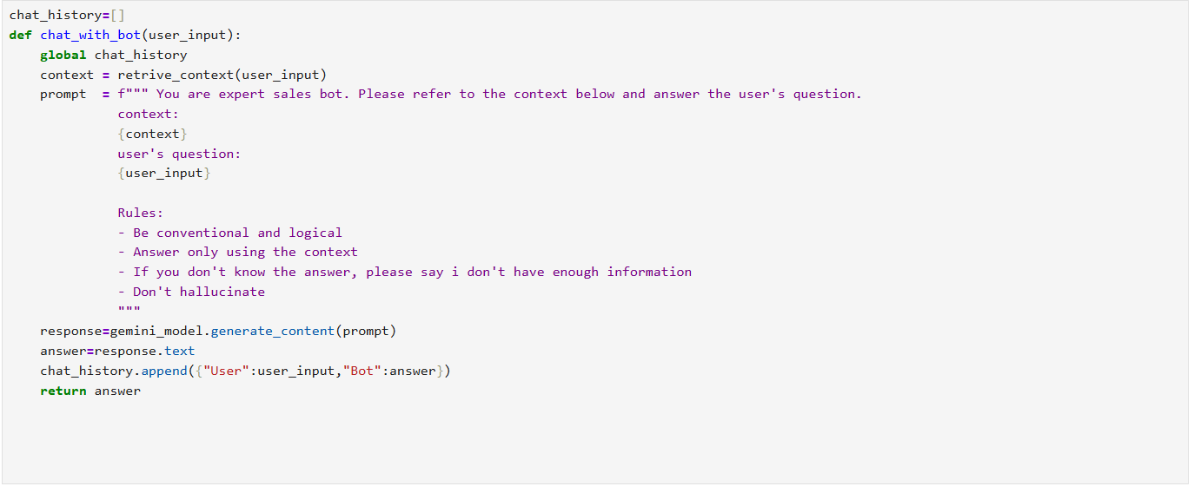
9.Final steps infinite loop until user press quite, bye, stop :
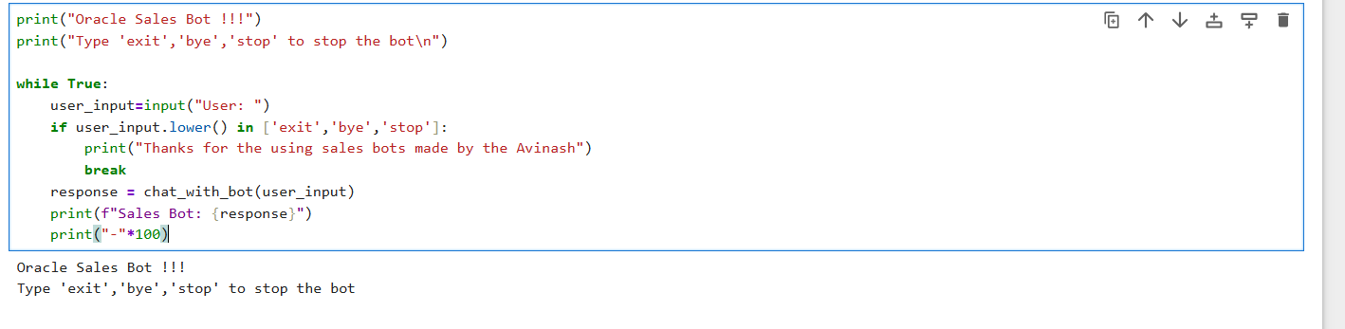
10. Now we will run code and provide the input:
What is the total sales ?
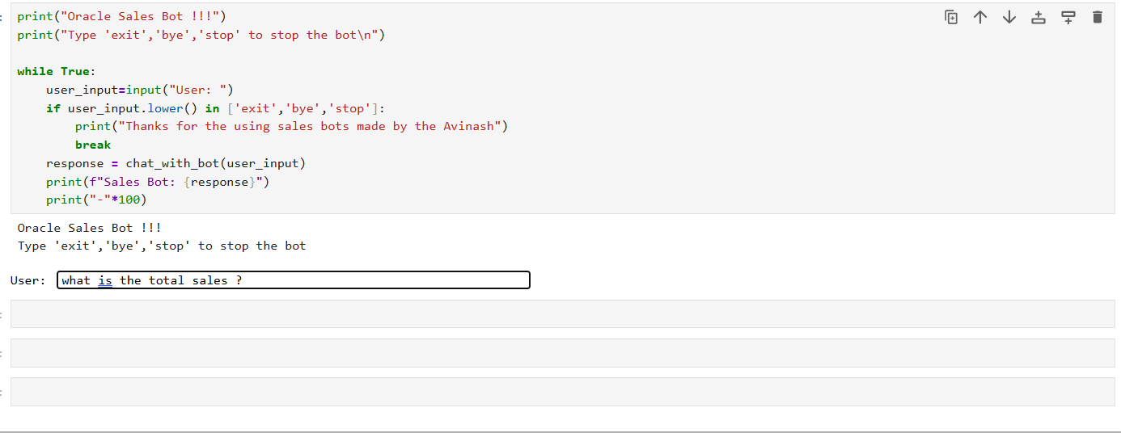
Answer :- 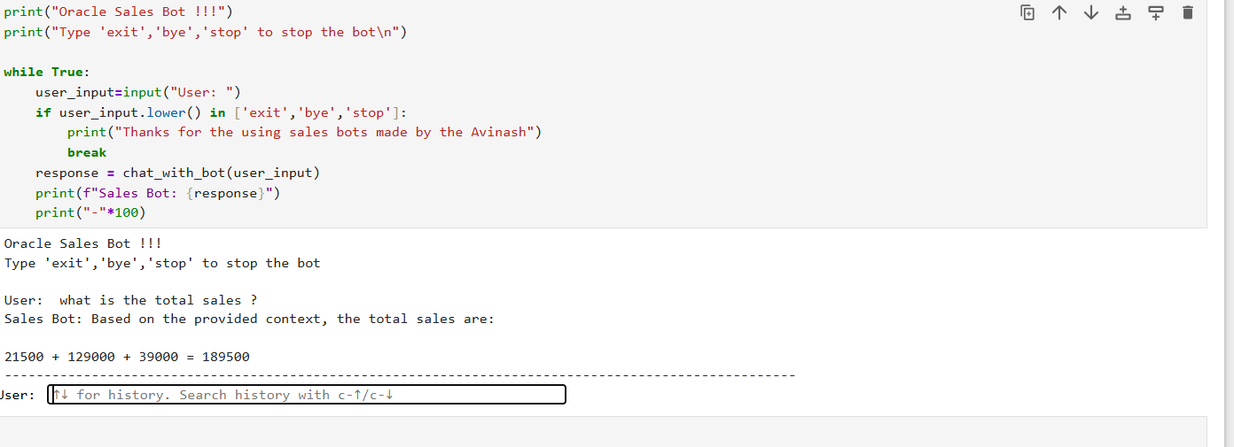
Next question:- which customer has highest sales ?
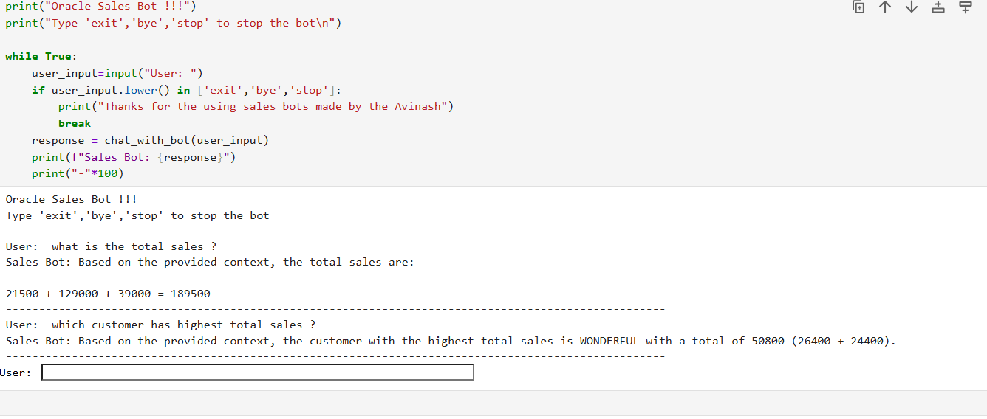

Next Question :- Give me the total sales of this customer: GBADAMOSI ALICE
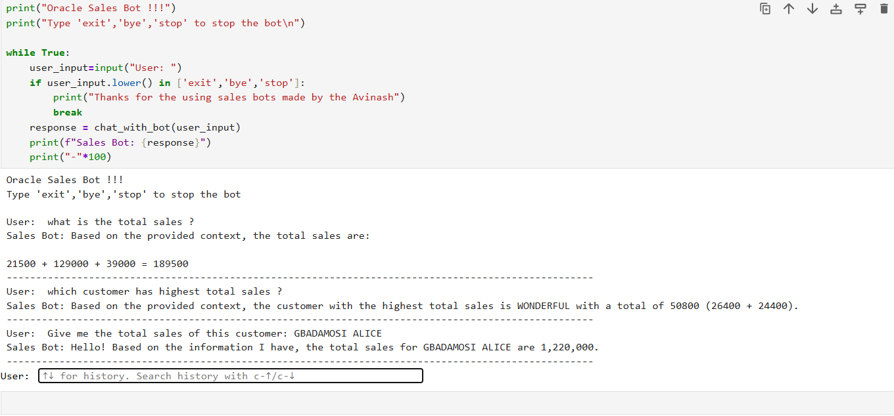
Next Question :- Please give me which customer highest sold quantity?
